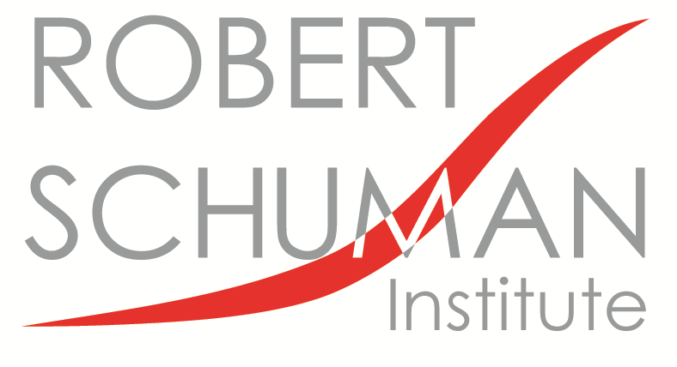
25 July, 2017

Call for Applications

“young Leaders” 2017/2018

We are pleased to inform you that the Robert Schuman Institute (RSI), with the support of the Eduardo Frei Foundation, starts again the series of courses entitled “Young Leaders” in October, 2017. The series will be provided for young politicians committed to the values of pluralist democracy in a Christian Democratic / centre-right approach, as represented by the European People’s Party (EPP), who are aiming to become future leaders in the Eastern and South-Eastern European countries (EE and SEE) such as Albania, Armenia, Belarus, Bosnia and Herzegovina, FYROMacedonia, Georgia, Kosovo, Moldova, Montenegro, Serbia and Ukraine, as well as Lebanon.

- Project description

Aim of the project:
- To provide theoretical and practical knowledge on political, social, cultural, economic and civic challenges and developments in Europe
- To reflect on the fundamental values of democracy, Christian Democracy, and those of the EPP family, with special emphasis on their practical implementation in concrete policies and decision making
- To promote the public roles and careers of young people belonging to parties / organisations of the EPP family in EE – SEE by means of education and training, information exchange and network-building

Target group:
Public career - oriented progressive young politicians between 22 – 30 years of age who are actively involved in parties from the EPP family.
(Approximately 20 young people from the above mentioned countries, with leading potential, selected on the basis of individual applications endorsed by relevant parties or organizations.)

Location: Budapest, Hungary

Working language: English

Pre-requisites:
- Applicants born between 1987-1995 October
- High level written and oral proficiency in English
- University/college degree (or at least four successfully completed semesters at university / college by the start of the first course)

- Structure of the series

Dates: Three 5-day courses as follows (draft):
1. Basics of a Democracy (10 - 14 October, 2017)
2. International and Security Issues (21 - 25 November, 2017)
3. Challenges in the Economic and Social Life (16 - 20 January, 2018)

Note: Arrivals are one day before and departures are one day after the given course dates.
Course topics: (depending also on participant expectations)

1. Basics of a Democracy:
- basic elements of democracy and civil society
- main political ideologies in Europe, main values of Christian Democracy
- value-based decision making, Christian Democratic values in concrete policy making
- political representation on the local level
- international norms for minority protection as collective standards of behaviour

incorruptible conducts by a politician as a basic principle
- the importance of a “sustainable lens” in political decision making
- religious communities and public life
- political education and the role of political foundations

2. International and Security Issues
- the post-Cold war institutional order
- crisis management in the international system
- functioning and structures of the European Union
- integration process, enlargement policy of the EU and Neighbourhood Policy
- NATO and EU in the current security architecture, relations with Russia
- demography, migration and energy as security factors
- international communication, shaping the image of a country

3. Challenges in the Economic and Social Life
      - nation states and international financial organisations
- globalisation and its impact on everyday policy making
- economics for politicians- from the basis to economy policies
- financial crisis and the Eurozone
- privatisation and foreign direct investments
- public private partnership in building regional economic capacity
- European economic policies, EU funds
- higher education reform: matching education to labour market needs
- dilemmas of designing social protection systems
- social dialogue, labour relations, trade unions, unemployment
- welfare system reform: retirement systems in an ageing Europe, the health sector
- women in SEE and EE and the development of democracy

Skill training and personal development (courses 1-3)
- team building
- communication and presentation skills
- debating and negotiation skills
- leadership and management

- Application process

The online application form should be filled at https://goo.gl/forms/PYNU0qK1RmySYwoN2

The following documents need to be sent to RSI by e-mail
(office@schuman-institute.eu), completely, arriving by the given deadline:

- A 2-page essay on the topic:
“Crucial issues for the development of my country: What I can do about them as a young leader”
- 2 letters of reference, signed and printed with official letterhead (and translated to English when necessary):
- one from the delegating party (not a youth organisation!), signed by a responsible official such as a Secretary General, Member of the Board, International Secretary, Foundation Director
- one from a person who knows the applicant and his/her activity in public life well (local party branch official, women’s organisation functionary, youth organisation leader, municipal councillor, NGO you work with, local KAS office etc.)
- Copy of diploma or a certificate issued by university/college (with English translation that can be your own) verifying that by the start of the course the applicant successfully completed at least four semesters at university / college
- Passport copy (just the main page with your data)

We will consider complete application packages only.
(Participants must bring their original reference letters to the first course)

Deadline for applications: 10 AM on 22 August (Tuesday), 2017 (arriving at RSI)

- Conditions of participation

- Preparation of all assignments before / during courses in compliance with the set deadlines
- Active and full participation in all 3 courses

Financial arrangements:

The costs of the course, including lectures, trainings as well as costs of full-board and lodging in double rooms will be covered by RSI.

Participants should have their travel costs be paid by their delegating party, or by themselves. The RSI may be able to make a contribution on the official request from the delegating organisation (included in the reference letter) if absolutely necessary. If RSI gives any travel cost contribution or reimbursement – including visa costs –, it has to be previously requested and agreed. Local transportation in Budapest as well as health insurance is to be covered by participants.

For further details please see a separate document on our travel support policy.

- Contacts

Organiser:
Robert Schuman Institute (HUNGARY, 1123 Budapest, Alkotás u. 5.)
e-mail: office@schuman-institute.eu
web: www.schuman-institute.eu

Attendance at each course of the series is mandatory from the first to the last day of the event as this is essential to efficient team-work and the aims of the series.

Should you require any further information about the series, please do not hesitate to contact us.

Gábor Berczeli
Acting Director

on behalf of Doris Pack MEPai, RSI President

This designation is without prejudice to positions on status, and is in line with UNSC 1244 and the ICJ Opinion on the Kosovo declaration of independence.

